**Boards**

**Work Items:**

* Work items contains all task, issues, bugs, epic etc.
* We can import work items from work item page.
* We can create new column for our work like assign to, created by etc.
* We can create new work item in form of epic issue or task.
* We can restore work item from recycle bin form work item page.

**Boards:**

* We have scrum board on board’s page to manage our work items.
* We have option like epic and issue to see which items on boards.
* We can manage our work in to-do doing or done status.
* We can check analytics of overall sprint to check that in which state our team is.
* We can filter our work item by mail or by date etc.

**Backlogs:**

* In scrum backlog is used for prioritizing requirements to show which requirement has high priority for starting.
* We can click on an issue or epic to show it in detail like its description date etc.
* We can create new column for our work like assign to, created by etc.

**Sprint:**

* Sprint is basically the time limit of 2 to 4 weeks’ time in scrum.
* We can see all our epic and issues on this page in current sprint
* We can see all our previous sprint form this page.
* We can see backlogs, capacity of our team in graph form, and analytics from sprint page.

**Queries:**

* If we have to filter something we give query.
* We have to filled fields and give value according to work items.
* We run it from query page.
* We can add new clause.
* We can see its result on result page.
* We can save our query for future review or use.
* We can add column in it.

**Delivery Plans:**

* Use the visualization options provided by the Delivery Plans feature of Azure Boards to review the schedule of stories or features that your teams plan to deliver.
* A delivery plan shows the scheduled work items by sprint (iteration path) of selected teams against a calendar view.

**NOTE**

Agile: Stories, Features, and Epics

Basic: Issues and Epics

Scrum: Backlog items, Features, and Epics

CMMI: Requirements, Features, and Epics

Epic (Basic, Agile, Scrum, and CMMI)

Feature (Agile, Scrum, and CMMI)

User Story (Agile), Product backlog item (Scrum), Requirement (CMMI)

Task (Basic, Agile, Scrum, and CMMI)

Impediment (Scrum), Issue (Agile and Basic)

Bug (Agile, Scrum, and CMMI)

**Azure Pipelines:**

* Go to pipelines
* Click on new pipeline
* Click on use the classic editor
* Select the source and click on continue.
* Click on empty job
* Add a job for deployment.
* Click on save and queue.

**Stages**

* Pipeline contain stages
* Stage is a collection of related jobs.
* Jobs is a collection of steps run by agent.
* Container reference is supported by jobs.
* Use of a matrix generates copies of a job, each with different input. These copies are useful for testing against different configurations or platform versions.
* This strategy specifies how many duplicates of a job should run. It's useful for slicing up a large test matrix.
* The Visual Studio Test task understands how to divide the test load across the number of scheduled jobs.
* A deployment job is a special type of job. It's a collection of steps to run sequentially against the environment. In YAML pipelines, we recommend that you put your deployment steps in a deployment job.
* A step is a linear sequence of operations that make up a job. Each step runs in its own process on an agent and has access to the pipeline workspace on a local hard drive. This behavior means environment variables aren't preserved between steps but file system changes are.
* A pull request trigger specifies which branches cause a pull request build to run.
* The pool keyword specifies which pool to use for a job of the pipeline. A pool specification also holds information about the job's strategy for running.

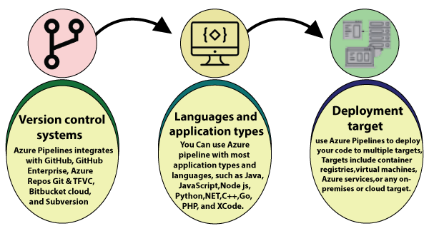

**Azure Repos:**

**Azure repos is used to manage your code.**

* **Commits**: When developer make some changes or code commit it to a branch or target.
* When developer complete code he push it to repository.
* Branches are the medium in a sense that developer push and pull.
* Pull request developer pull a request for showing a change or code to everyone in team.
* Tags are comments in a sense to show a thing or item attached to something.
* Repos contain file and folders also which show overall record.